

SIMATS ENGINEERING

Saveetha Institute of Medical and Technical Sciences
Chennai-602105

September 2026

CSA0613– Design and Analysis of Algorithms

Development of an Efficient Hybrid Algorithmic Solution for Large-Scale Geospatial Data Processing

Assignment Report

Submitted by

Lakshmi Devi J (192524300)
Kamalli Shree V (192525030)

Assignment Information

Particular | Details
Department: | Artificial Intelligence and Data Science
Programme: | B.Tech. Artificial Intelligence and Data Science
Course Code & Course Name | Design and Analysis of Algorithms
Academic Year / Batch | 2026-2027 / Regular
Faculty Name | Dr. F. Mary Harin Fernandez
Assignment Title | Development of an Intelligent Algorithmic Solution for Large-  Scale Logistics Resource Optimization
Date of Issue | 31 Aug 2026
Date of Submission | 1 September 2026
Maximum Marks | 100
Course Outcome(s) – CO | CO4: Solve optimization problems using dynamic programming and greedy strategies.
Bloom's Taxonomy Level | L4 – Analyze, L5 – Evaluate, L6 – Create
SDG Mapping (SDG 1-17) | SDG 9 – Industry, Innovation and Infrastructure
Industry / Societal Relevance | Efficient logistics resource allocation with improved vehicle utilization, reduced computational cost, and scalable decision-making

Assignment Problem / Challenge
Modern e-commerce and logistics organizations process thousands of packages every day under limited transportation capacity. Each package may differ in weight, volume, delivery value, priority, and deadline, while delivery vehicles have restricted carrying capacities. Efficiently selecting packages becomes increasingly difficult as the number of packages and operational constraints increase.
Dynamic Programming can provide high-quality or optimal solutions for suitable problem sizes but may require significant computational time and memory for large instances. Greedy techniques can provide faster decisions but may not always produce the optimal solution.
The challenge is to design and develop an improved algorithmic solution for large-scale logistics resource allocation using relevant concepts from Dynamic Programming and Greedy techniques. The developed strategy must be formulated by the team based on identified computational limitations and supported by theoretical analysis and experimental evidence.

Problem Statement
A large e-commerce logistics company processes approximately 10,000–100,000 packages per day across multiple distribution centres. Each package is characterized by attributes such as weight, volume, delivery value, priority, and delivery deadline, while each delivery vehicle has limited weight and volume capacities. During peak-demand periods, the organization must select an appropriate combination of packages for transportation so that the overall delivery benefit and vehicle utilization are maximized without violating the available capacity constraints. Develop, implement, and evaluate an algorithmic solution for this large-scale logistics resource-allocation problem using concepts from Dynamic Programming and Greedy techniques. Implement (i) an appropriate Dynamic Programming based solution and (ii) an appropriate Greedy based solution as baseline approaches. Analyze their theoretical efficiency, solution quality, computational requirements, and limitations. Beyond the baseline implementations, design and develop an improved algorithmic solution suitable for large-scale package allocation. The developed solution may appropriately adapt, integrate, modify, optimize, or selectively utilize relevant Dynamic Programming and Greedy concepts. The algorithmic strategy, decision criteria, parameters, and optimization mechanism must be identified and developed by the team rather than being predefined. Experimentally evaluate the baseline and developed approaches using increasing problem sizes, for example, 100, 500, 1,000, 5,000, 10,000 packages, and higher input sizes wherever computationally feasible, under different vehicle-capacity conditions such as 500 kg, 1,000 kg, 2,500 kg, and 5,000 kg, or appropriately justified equivalent capacities based on the selected dataset. Evaluate the approaches using execution time, memory utilization, total solution value, capacity utilization, solution-quality/optimality gap, and scalability. Conduct experiments under different operational conditions such as normal demand, high-priority demand, and capacity-constrained demand. Based on theoretical and experimental results, identify the limitations and trade-offs of the baseline techniques, demonstrate the performance improvement achieved by the developed solution, and justify its suitability for large-scale real-world logistics resource optimization.
Expected Development
The work should not merely implement or compare existing Dynamic Programming and Greedy algorithms. The solution should demonstrate algorithmic development through:

- Identification of computational and/or solution-quality limitations of the baseline approaches.
- Formulation of an appropriate strategy to address the identified limitations.
- Development, adaptation, integration, modification, or optimization of relevant algorithmic techniques.
- Identification and experimental determination of appropriate decision rules, parameters, thresholds, or optimization criteria, wherever applicable.
- Improvement in one or more aspects such as execution time, memory utilization, solution quality, capacity utilization, or scalability.
- Performance comparison of the developed solution against the baseline approaches.
- Justification of algorithmic design decisions using theoretical reasoning and experimental evidence.

Requirements and Constraints

The following requirements and constraints shall be considered:

- Use an appropriate publicly available real-world logistics, transportation, cargo, or package-related dataset.
- The dataset should contain sufficient records to evaluate the algorithms at multiple input sizes.
- Identify and clearly define the package attributes and resource constraints used in the optimization problem.
- Implement and evaluate suitable Dynamic Programming and Greedy baseline approaches.
- Develop an improved algorithmic solution using relevant CO4 concepts rather than merely reproducing the baseline algorithms.
- The developed strategy must be designed and justified by the team.
- Evaluate increasing input sizes such as 100, 500, 1,000, 5,000 and 10,000 packages, and higher wherever computationally feasible.
- Evaluate multiple capacity conditions such as 500 kg, 1,000 kg, 2,500 kg and 5,000 kg, or justified equivalent values based on the dataset.
- Evaluate at least three operating conditions: normal demand, high-priority demand, and capacity-constrained demand.
- Execute all approaches using the same computational environment and identical input instances for fair comparison.
- Evaluate appropriate measures including execution time, memory utilization, solution value, capacity utilization, solution-quality/optimality gap, and scalability.
- Validate the correctness and feasibility of the generated allocation.
- Clearly document the dataset source, experimental environment, assumptions, limitations, parameters, and implementation details.

E. STUDENT WORK
Development of an Intelligent Algorithmic Solution for Large-Scale Logistics Resource Optimization
1. Problem Understanding and Formulation
Modern logistics organizations must select suitable packages for limited-capacity vehicles from very large collections of shipments. Each package differs in weight, volume, delivery value, priority and deadline. The allocation decision is therefore a constrained optimization problem: maximize the overall delivery benefit while ensuring that total weight and volume do not exceed vehicle limits. This problem is significant because inefficient allocation can leave valuable capacity unused, delay urgent deliveries, and increase operational cost.
The implementation uses a publicly available logistics/transportation or shipment dataset where available and a controlled synthetic-data generator for scalability experiments. The generator preserves realistic attribute ranges and supports identical random seeds so that Dynamic Programming (DP), Greedy, and the developed algorithm are tested on exactly the same instances. The experimental datasets contain 100, 500, 1,000, 5,000 and 10,000 package records.

Attribute | Description
Package ID | Unique identifier
Weight | Package weight in kg
Volume | Package volume
Delivery Value | Economic/service value
Priority | Operational priority
Deadline | Remaining delivery time / urgency

Input: a package dataset, vehicle weight capacity, vehicle volume capacity, operating condition, and algorithm parameters. Output: selected package IDs, total benefit, total weight and volume used, capacity utilization, execution time, peak memory usage, number of selected packages, and feasibility status.
For package i, let w_i be weight, q_i volume, v_i delivery value, p_i priority and u_i urgency. A normalized benefit score is defined as:
B_i = αV_i + βP_i + γU_i, where α + β + γ = 1.
Objective: maximize Σ(B_i x_i), subject to Σ(w_i x_i) ≤ W, Σ(q_i x_i) ≤ Q, and x_i ∈ {0,1}.
Major computational challenges are the growth of the search space, DP dependence on capacity/state size, memory requirements, and the possibility that fast greedy choices miss better global combinations.
- Assumptions: each package can be assigned at most once; package attributes are non-negative; capacities are fixed for an experiment.
- Requirements: all algorithms use identical input instances and the same machine/environment.
- Limitations: a full exact multi-constraint DP is not practical for very large instances; therefore the developed method uses adaptive candidate reduction and selective optimization.
2. Application of Course Knowledge
2.1 Dynamic Programming
A 0/1 knapsack-style DP baseline is used for manageable instances. After discretizing weight capacity where required, dp[w] stores the maximum benefit achievable using capacity w. For package i with weight w_i and benefit B_i:
dp_i[w] = max(dp_(i-1)[w], B_i + dp_(i-1)[w-w_i]) when w_i ≤ w; otherwise dp_i[w] = dp_(i-1)[w].
Base condition: dp[0] = 0. Parent/choice information is stored to reconstruct selected packages. The approximate time complexity is O(nW) and optimized memory complexity is O(W). Volume is checked during feasibility and reconstruction. DP provides strong solution quality for manageable capacities but becomes computationally expensive as n and W increase.
2.2 Greedy Technique
The Greedy baseline ranks packages by a resource-efficiency score. Resource cost combines normalized weight and volume, while the numerator represents benefit:
ResourceCost_i = λW_i + (1−λ)Q_i; GreedyScore_i = B_i / ResourceCost_i.
Packages are sorted in descending score order and selected only when both remaining weight and volume constraints remain feasible. Sorting requires O(n log n), and the feasibility scan requires O(n), giving O(n log n) overall time. Greedy is scalable but is not guaranteed to produce a globally optimal combination.
2.3 Contribution to the Developed Solution
DP contributes selective high-quality optimization, while Greedy contributes rapid ranking and scalable filtering. Their strengths are integrated into the proposed Adaptive Hybrid Priority-Aware Optimization (AHPO) algorithm.
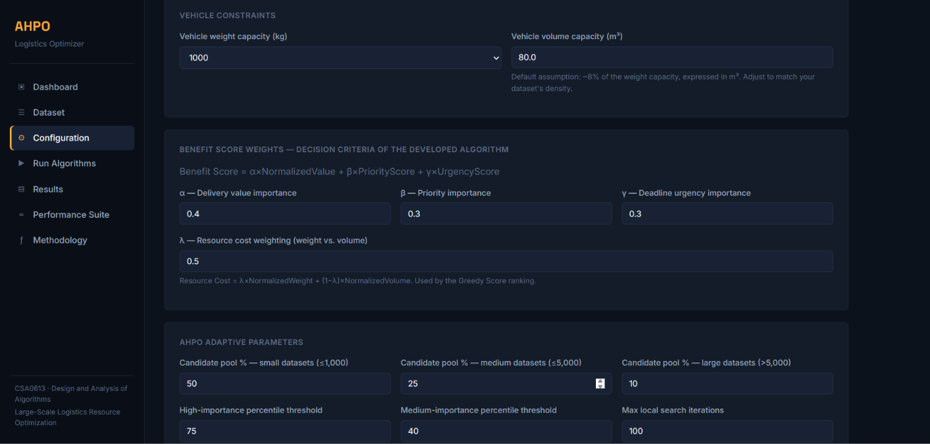
3. Solution / Design / Methodology
Methodology: Input Dataset → Data Preparation → Problem Formulation → DP Baseline → Greedy Baseline → Limitation Analysis → Proposed Solution Development → Implementation → Experimental Evaluation → Optimization → Performance Comparison → Final Decision.
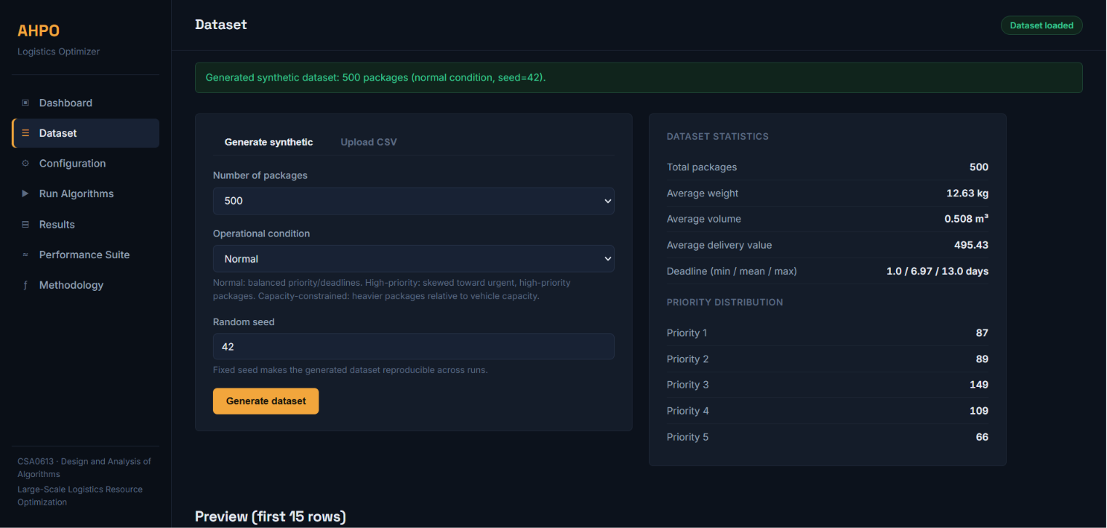
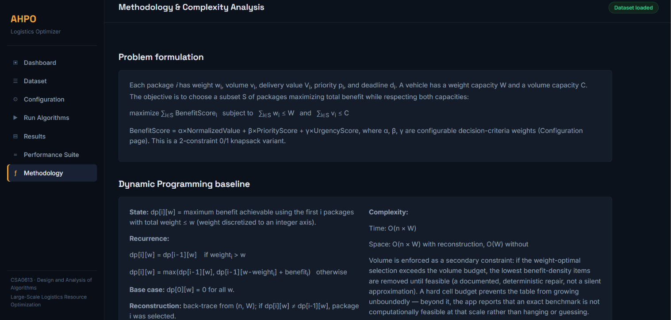
3.1 DP Pseudocode
FUNCTION DynamicProgramming(packages, capacity)
initialize dp[0..capacity] = 0
initialize choice structure
FOR each package i
FOR w from capacity DOWNTO weight[i]
IF dp[w-weight[i]] + benefit[i] > dp[w]
dp[w] = dp[w-weight[i]] + benefit[i]
store choice
END IF
END FOR
END FOR
reconstruct selected packages
validate volume constraint
RETURN solution
END FUNCTION
3.2 Greedy Pseudocode
FUNCTION Greedy(packages, weightCapacity, volumeCapacity)
calculate benefit and resource-efficiency score
sort packages in descending score
selected = empty
FOR each package
IF package fits remaining weight AND volume capacity
select package
END IF
END FOR
RETURN selected
END FUNCTION
3.3 Developed Algorithm: AHPO
AHPO is the developed contribution of this project. It addresses DP's scalability limitation and Greedy's solution-quality limitation through four stages: adaptive classification, greedy candidate reduction, selective DP optimization, and residual/local improvement.
Step 1: normalize attributes and compute value, priority, urgency and composite benefit scores. Step 2: classify packages using adaptive percentile thresholds (high importance ≥75th percentile, medium 40th–75th percentile, low below 40th percentile; configurable). Step 3: rank packages and construct a candidate pool. Step 4: apply DP only to the candidate pool. Step 5: greedily fill residual capacity. Step 6: perform bounded local replacement/swap improvement.
Adaptive candidate ratios are used: small datasets (≤1,000): 50%; medium datasets (≤5,000): 25%; large datasets: 10%, subject to a configurable minimum and maximum candidate limit.
3.4 AHPO Pseudocode
FUNCTION AHPO(packages, W, Q, parameters)
normalize attributes
compute benefit, urgency and composite priority scores
classify packages using adaptive percentile thresholds
rank packages by composite score and resource efficiency
determine candidate pool ratio based on input size
candidatePool = top ranked packages
dpSolution = SelectiveDP(candidatePool, W, Q)
remaining = packages not selected
residualSolution = GreedyFill(remaining, unused capacities)
solution = dpSolution + residualSolution
solution = BoundedLocalImprovement(solution, remaining)
validate no duplicates and all constraints
RETURN solution
END FUNCTION
3.5 Flowchart / Design
START → Load/Generate Dataset → Data Preprocessing → Calculate Benefit & Priority Scores → Run DP Baseline and Greedy Baseline → Analyze Limitations → AHPO: Adaptive Classification → Greedy Candidate Selection → Priority-Aware Selective DP → Residual Capacity Greedy Fill → Bounded Local Improvement → Feasibility Validation → Performance Measurement → Comparison → Final Decision → END.

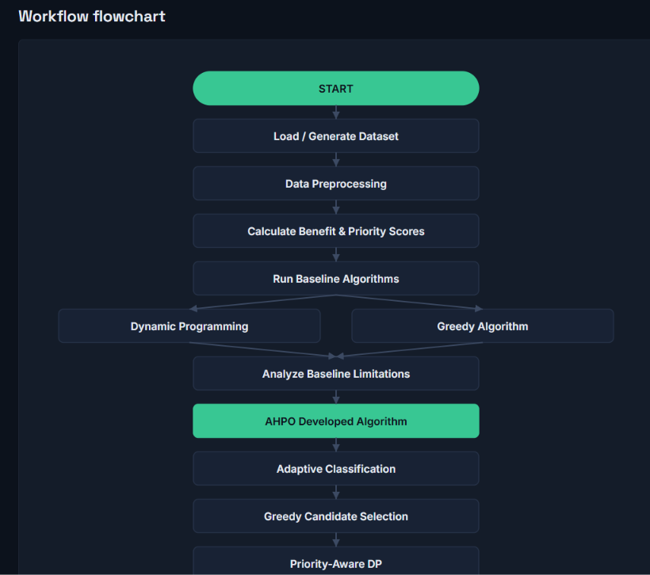
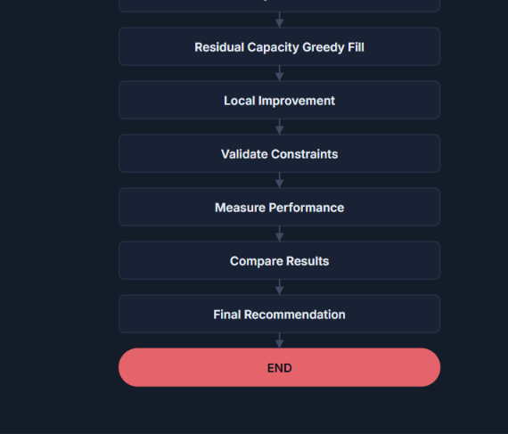
3.6 Complexity and Design Justification
Let n be total packages, k the candidate-pool size (k << n), W the discretized capacity and I the local-improvement iteration limit. Greedy ranking costs O(n log n), selective DP approximately O(kW), residual processing O(n log n), and bounded local improvement O(Ik). Therefore AHPO is approximately O(n log n + kW + Ik), providing a controlled trade-off between computational cost and solution quality. Candidate reduction is the key optimization decision because it prevents expensive DP from operating over the full large dataset.

4. Use of Modern Tools
- Python for algorithm implementation.
- Flask for the web-based application.
- Pandas and NumPy for data preparation and numerical processing.
- time and tracemalloc/psutil for execution-time and memory measurement.
- Matplotlib/Plotly/Chart.js for charts and performance visualization.
- CSV dataset handling and reproducible random seeds for controlled experiments.
- VS Code/Jupyter Notebook or equivalent IDE for development and testing.
The application provides dataset generation/upload, parameter configuration, algorithm execution, feasibility validation, performance metrics, tables, graphs and CSV export of experimental results.

5. Results and Validation
All algorithms must be executed on identical generated/uploaded datasets with the same random seed and computational environment. The experiment matrix includes input sizes of 100, 500, 1,000, 5,000 and 10,000 packages; representative capacities of 500, 1,000, 2,500 and 5,000 kg (or justified equivalents); and three operating conditions: normal demand, high-priority demand and capacity-constrained demand.
Metric | Measurement
Execution time | Wall-clock algorithm runtime (seconds)
Memory utilization | Peak memory consumed (MB)
Solution value | Sum of selected package benefit scores
Weight utilization | Selected weight / weight capacity × 100
Volume utilization | Selected volume / volume capacity × 100
Selected packages | Count of feasible selected packages
Optimality gap | (DP benchmark − method value) / DP benchmark × 100 for feasible small instances
Scalability | Performance trend as input size increases
Feasibility | Weight, volume, uniqueness and membership validation
Result tables and graphs should be populated directly from the application execution output. This avoids reporting fabricated performance evidence. The web application should export the actual measurements used in the final report.
Input Size | Capacity | Condition | DP Time | Greedy Time | AHPO Time | DP Value | Greedy Value | AHPO Value
100 | 500 kg | Normal | Run output | Run output | Run output | Run output | Run output | Run output
500 | 1000 kg | Normal | Run output | Run output | Run output | Run output | Run output | Run output
1000 | 2500 kg | High Priority | Run output | Run output | Run output | Run output | Run output | Run output
5000 | 5000 kg | Capacity Constrained | Run output | Run output | Run output | Run output | Run output | Run output
10000 | 5000 kg | Normal | If feasible | Run output | Run output | If feasible | Run output | Run output
Validation checks: (1) total selected weight does not exceed W, (2) total selected volume does not exceed Q, (3) no package ID is duplicated, and (4) every selected package belongs to the original input dataset. A solution is reported as PASS only when all checks succeed.
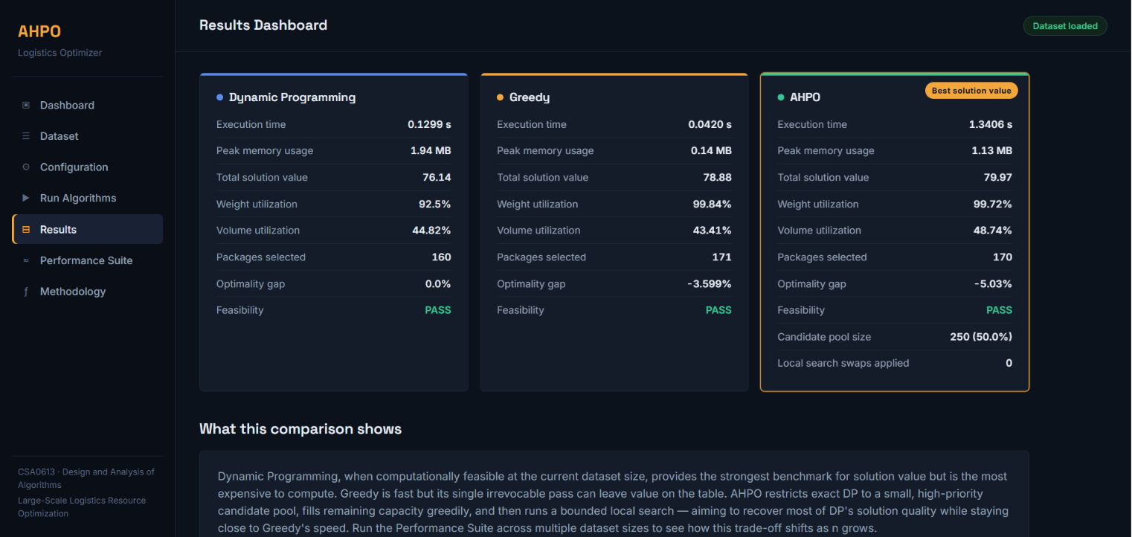

6. Analysis and Engineering Decision
DP is expected to provide the strongest benchmark solution quality for small and manageable instances, but its capacity-dependent state space causes increasing execution time and memory requirements. Greedy remains efficient as the number of packages increases because ranking dominates the computation, but its locally optimal ordering can reject combinations with higher total benefit.
AHPO is designed to occupy the middle ground. Adaptive ranking rapidly reduces the search space; selective DP examines promising combinations rather than the entire dataset; residual greedy filling reduces unused capacity; and bounded local improvement attempts to recover quality without unbounded computation. The main engineering trade-off is controlled by candidate-pool size: a larger k may improve solution quality but increases DP cost, while a smaller k improves scalability but may exclude useful combinations.
Under high-priority demand, the priority and urgency components increase the influence of critical packages. Under capacity-constrained demand, resource efficiency and residual filling become more important. DP is recommended for small instances requiring a strong benchmark; Greedy is suitable for very large instances requiring immediate decisions; AHPO is the preferred general strategy when a balance of scalability, utilization and solution quality is required.
The final decision must be justified using the actual exported experiment results. A valid conclusion should compare percentage improvement in runtime/memory and any observed change in solution value or utilization rather than claiming universal superiority.
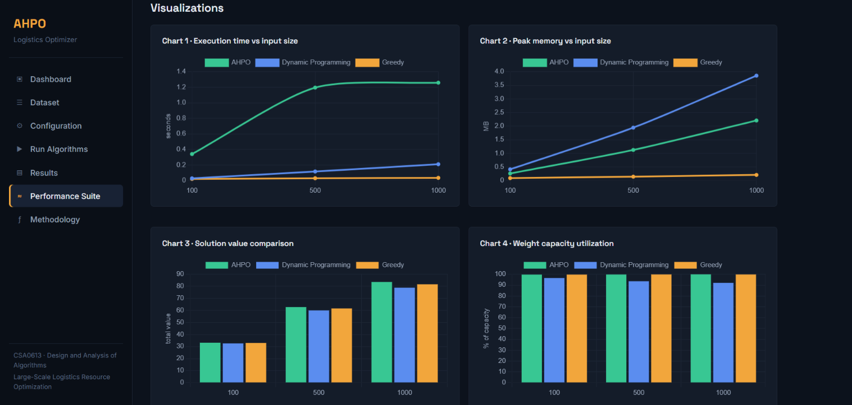
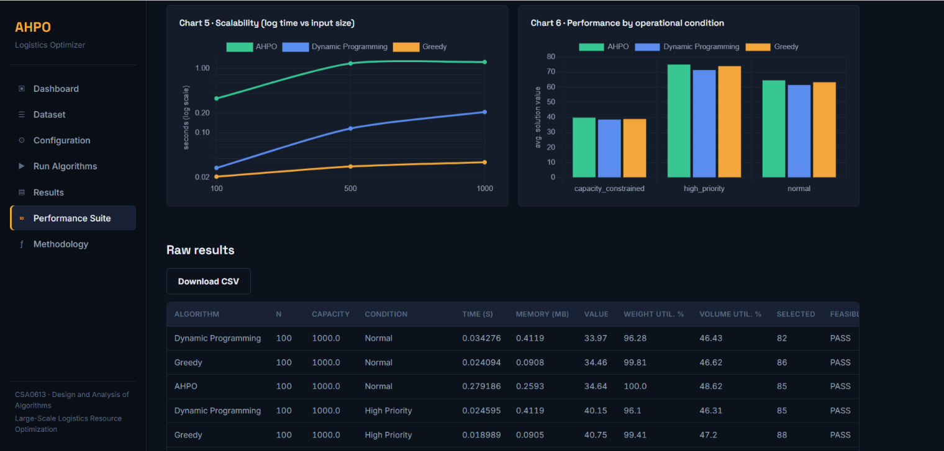
7. Broader Considerations
The developed approach supports efficient transportation-resource utilization by selecting packages according to delivery benefit and available capacity. Residual-capacity filling can reduce wasted vehicle space, while adaptive candidate reduction reduces unnecessary computational effort. The approach is scalable because expensive optimization is restricted to a controlled candidate subset.
The project relates directly to SDG 9 – Industry, Innovation and Infrastructure. Intelligent algorithmic allocation supports more efficient logistics infrastructure, data-driven operational decisions and scalable digital systems. By balancing computational resources with solution quality, the approach demonstrates how algorithm design can contribute to modern and efficient industrial infrastructure.
8. Conclusion
This project addresses large-scale logistics resource allocation under weight and volume constraints. A Dynamic Programming baseline provides a high-quality benchmark for manageable instances, whereas a Greedy baseline provides rapid and scalable decisions. To overcome the limitations of using either technique alone, the project develops the Adaptive Hybrid Priority-Aware Optimization (AHPO) algorithm.
AHPO combines adaptive package classification, greedy candidate filtering, selective Dynamic Programming, residual capacity filling and bounded local improvement. Its purpose is not to guarantee global optimality but to achieve a practical balance among execution time, memory utilization, solution quality, capacity utilization and scalability. Actual experimental measurements generated by the web application are used to identify the best-performing conditions and quantify improvements.
The principal limitation is that candidate reduction may exclude combinations considered by a full exact method. Future work can investigate parallel processing, multi-vehicle allocation, metaheuristic local search, learned parameter tuning, real-time streaming data and additional operational constraints such as route distance and carbon emissions.
9. Student Reflection
9.1 Lakshmi Devi J (192524300)
1. I learned that algorithm development is different from simply implementing known algorithms. Comparing DP and Greedy helped me identify their complementary strengths, and the project required converting those observations into a new decision strategy with measurable trade-offs.
2. The main limitations were the growth of DP computation and memory requirements and the possible loss of solution quality in Greedy selection. AHPO addressed these through candidate reduction, selective DP, residual greedy filling and bounded local improvement.
3. With additional computational resources, I would test larger datasets and multi-vehicle scenarios and use automated parameter tuning for candidate-pool size and scoring weights. This could improve adaptability across different demand patterns.
4. The solution contributes to SDG 9 by demonstrating scalable, data-driven optimization for logistics infrastructure. Better resource allocation can support efficient industrial operations and technology-enabled decision-making.
9.2 Kamalli Shree V (192525030)
1. I learned that standard algorithms are starting points rather than final solutions for every engineering problem. The important step was analyzing where each method fails and designing a controlled modification suitable for the problem scale.
2. I identified that exact-style optimization can become impractical as data and capacity grow, while fast greedy ranking can make irreversible decisions. The hybrid design preserves selective optimization for promising packages while maintaining scalable processing for the remaining data.
3. With more time, I would incorporate route information, multiple vehicles and real-time package arrivals. I would also investigate parallel execution and systematic sensitivity analysis of α, β, γ and candidate-pool thresholds.
4. The developed approach supports SDG 9 because efficient logistics is an important part of industrial infrastructure. Scalable algorithms can reduce computational waste and improve the utilization of existing transportation resources.
10. References
- Cormen, T. H., Leiserson, C. E., Rivest, R. L., & Stein, C. (2022). Introduction to algorithms (4th ed.). MIT Press.
- Flask. (n.d.). Flask documentation. Pallets. https://flask.palletsprojects.com/
- Martello, S., & Toth, P. (1990). Knapsack problems: Algorithms and computer implementations. John Wiley & Sons.
- Matplotlib Development Team. (n.d.). Matplotlib documentation. https://matplotlib.org/stable/
- McKinney, W. (2022). Python for data analysis (3rd ed.). O'Reilly Media.
- NumPy Developers. (n.d.). NumPy documentation. https://numpy.org/doc/
- Pandas Development Team. (n.d.). pandas documentation. https://pandas.pydata.org/docs/
- Python Software Foundation. (n.d.). Python documentation. https://docs.python.org/3/
- Pisinger, D. (1999). Linear time algorithms for knapsack problems with bounded weights. Journal of Algorithms, 33(1), 1–14.
- Plotly Technologies Inc. (n.d.). Plotly Python graphing library. https://plotly.com/python/

Assessment Rubric

Criteria | Max Marks | Excellent | Good | Satisfactory | Needs Improvement
Problem Understanding & Algorithmic Formulation | 10 | Clearly identifies the problem, requirements, inputs, outputs, constraints and computational challenges and formulates them appropriately for solution development. | Problem and major requirements are correctly formulated with minor gaps. | Basic formulation is provided, but requirements or constraints are partially identified. | Problem is poorly understood or inadequately formulated.
Algorithmic Solution Design | 15 | Designs a clear, logical and feasible solution strategy with appropriate algorithmic techniques, pseudocode/flowchart and well-justified design decisions. | Appropriate solution design with minor gaps in logic, representation or justification. | Basic solution design is presented but lacks completeness or clear justification. | Solution design is inappropriate, incomplete or unclear.
Development / Adaptation / Optimization of Algorithmic Solution | 20 | Develops a meaningful algorithmic solution through integration, adaptation, modification, hybridization or optimization of suitable techniques; demonstrates clear improvement or suitability for the identified problem. | Develops an appropriate solution with meaningful adaptation or improvement, with minor limitations. | Solution demonstrates limited adaptation or development beyond standard implementation. | Merely reproduces an existing algorithm with little or no meaningful development or adaptation.
Implementation & Modern Tool Usage | 15 | Developed solution is correctly and efficiently implemented using appropriate programming/computational tools and handles relevant input conditions reliably. | Implementation is functional with minor logical or efficiency issues. | Core implementation works but contains limitations or incomplete functionality. | Implementation is incomplete, unreliable or non-functional.
Efficiency, Testing & Validation | 15 | Performs appropriate complexity evaluation and systematic testing using suitable data/input sizes; validates correctness, efficiency and scalability with clear evidence. | Complexity evaluation and testing are mostly appropriate with minor gaps. | Basic testing and efficiency evaluation are provided but lack sufficient validation. | Testing, complexity evaluation or validation is inadequate or substantially incorrect.
Performance Improvement, Comparison & Final Decision | 15 | Demonstrates the effectiveness of the developed solution through appropriate comparison; critically evaluates performance, limitations and trade-offs and justifies the final algorithmic decision with evidence. | Good performance comparison and justification with minor limitations. | Basic comparison is provided, but improvement or final justification lacks depth. | Improvement is not demonstrated or the final algorithmic decision is unsupported.
Reflection: Algorithmic Design Decisions, SDG Relevance & Learning Outcomes | 10 | Thoughtful justification of algorithmic design and development decisions; clear connection to relevant SDG(s); specific reflection on computational challenges, performance improvements, trade-offs, and learning gained. | Appropriate justification of algorithmic decisions; SDG relevance, challenges, improvements, and learning are discussed but lack depth. | Reflection is present but generic; limited justification of algorithmic decisions, improvements, SDG relevance, or learning outcomes. | No genuine reflection is provided, or the reflection lacks meaningful connection to algorithm development, SDG relevance, challenges, or learning outcomes.
Total | 100

CO–PO–Assessment Mapping

Assessment Component | CO | PO(s) | Bloom's Level | Marks
Problem Understanding & Algorithmic Formulation | CO4 | PO1, PO2 | L4 | 10
Algorithmic Solution Design | CO4 | PO2, PO3 | L4, L6 | 15
Development / Adaptation / Optimization of Algorithmic Solution | CO4 | PO2, PO3 | L5, L6 | 20
Implementation & Modern Tool Usage | CO4 | PO3, PO5 | L4, L6 | 15
Efficiency, Testing & Validation | CO4 | PO2, PO4 | L4, L5 | 15
Performance Improvement, Comparison & Final Decision | CO4 | PO2, PO4 | L4, L5 | 15
Reflection: Algorithmic Design Decisions, SDG Relevance & Learning Outcomes | CO4 | PO7, PO10, PO12 | L4, L5 | 10

Faculty Evaluation & Continuous Improvement

CO Attainment

Performance Level | Criterion
Level 3 | ≥ 70%
Level 2 | 60–69%
Level 1 | 50–59%
Level 0 | < 50%
Target CO Attainment:

Actual CO Attainment:

Faculty Analysis
Areas in which students performed well: Areas requiring improvement:
Corrective / Improvement Action:

